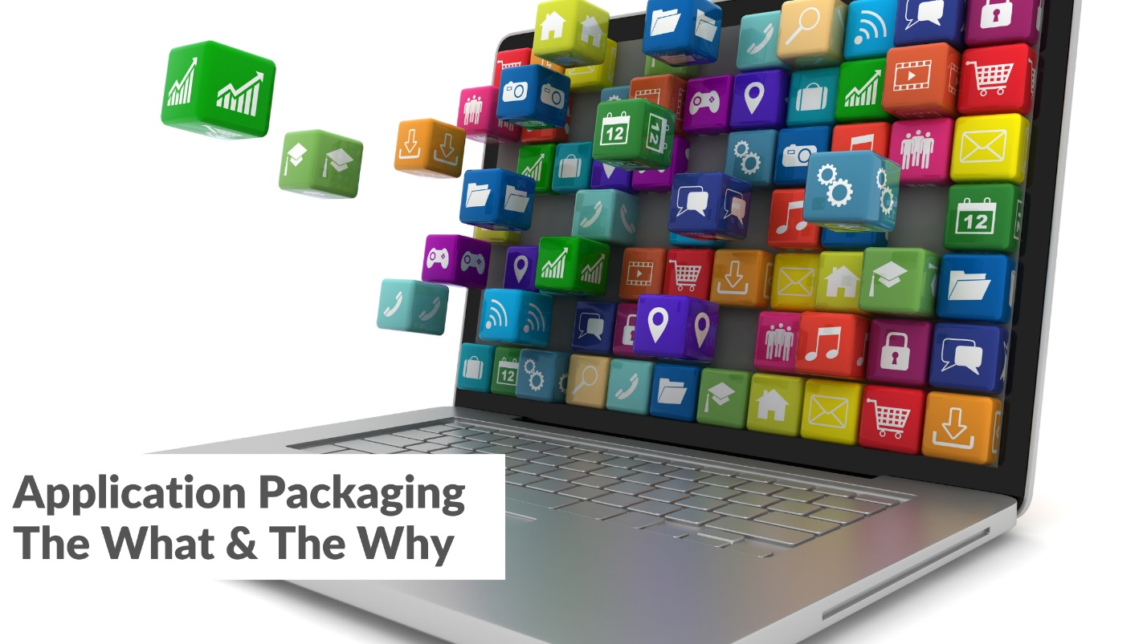

**What is Application Packaging?**

**Application Packaging** means collecting all the files, settings, and information needed to install a software program into one single bundle or package. This makes it easy to install the software on other computers without missing any important parts.

Application packaging is the process of preparing software which can be easily installed, updated or removed on many computers together.

Any code needs to be converted into a software deployable package first.

Application packaging updates different versions of softwares which is also called as Software as a Service apps package.

**Why is Application Packaging Useful?**

Application packaging is helpful for many reasons:

* It **saves time** because everything is already prepared.
* **Installation becomes faster and easier**.
* It helps avoid mistakes during setup, like missing files or wrong settings.
* It’s great for installing apps on many computers at once, especially in offices or schools.

**How to Install an App Using an MSIX Package**

1. **Check if your system supports MSIX.**
2. **Download the MSIX file.**
3. **Find the MSIX file.**
4. **Double-click the MSIX file.**
5. **Click Install.**
6. **Wait for the installation to finish.**
7. **Open the app.**

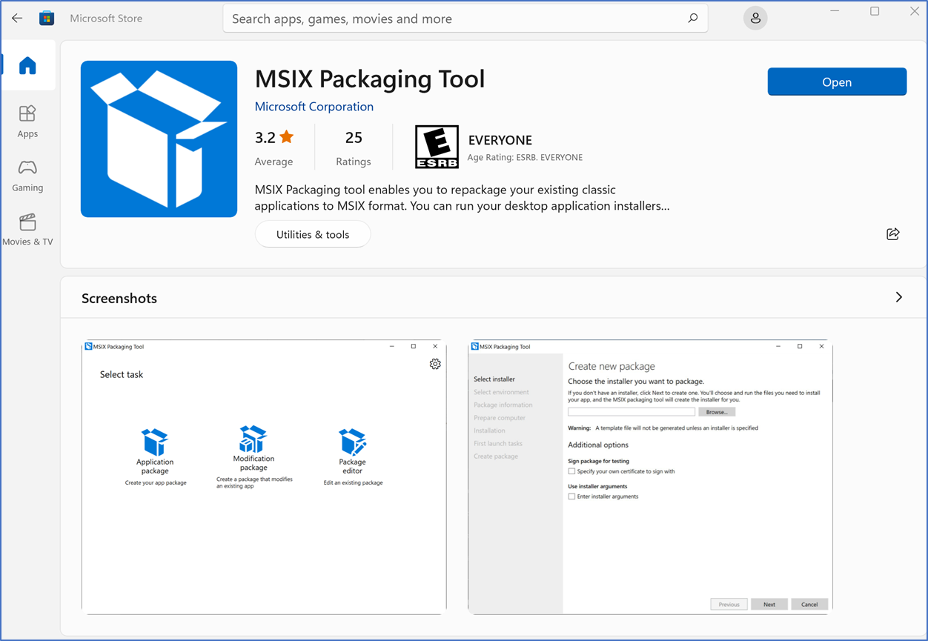

**End-To-End Application Packaging Process:**

